**CICD FOR DINO**

* CICD includes below 3 services of AWS
  + ECS
  + ECR
  + Codebuild

Below are the steps to create ECR, ECS and Codebuild.

* ECR
  + Open ECR ( Elastic container registry)  
    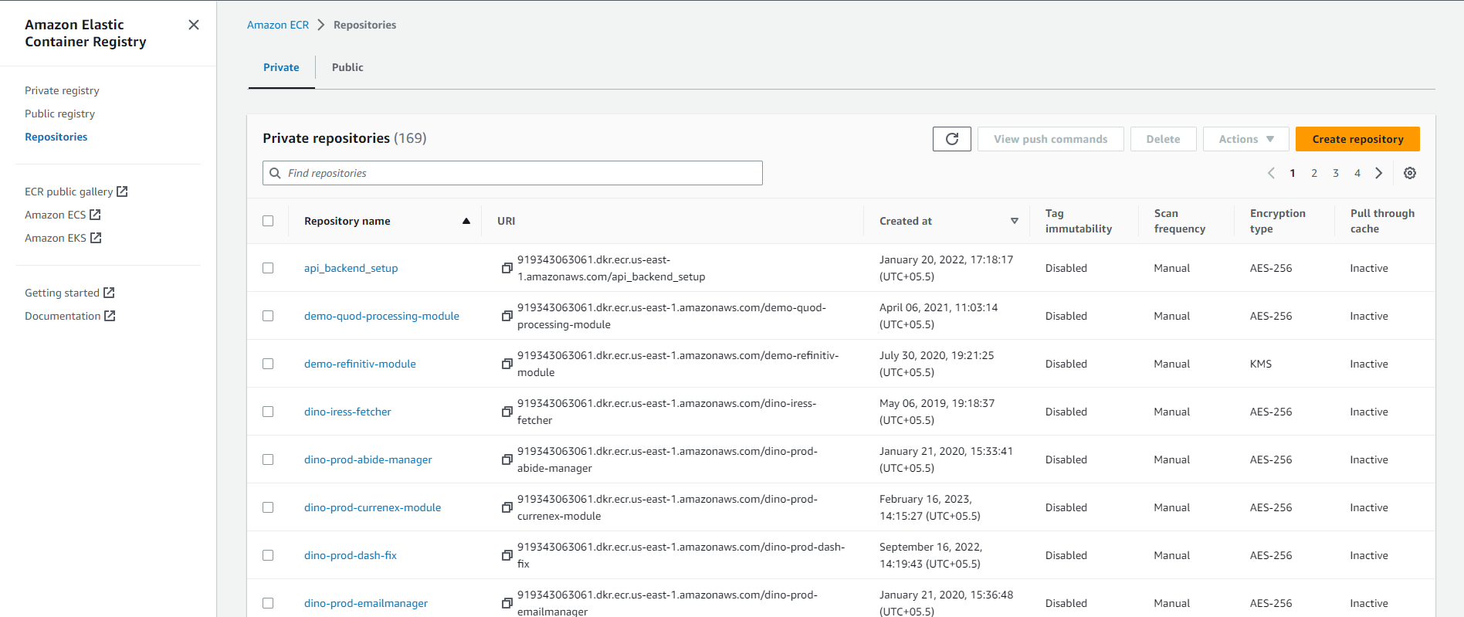
  + Click on create repository  
    We need to select private repository  
    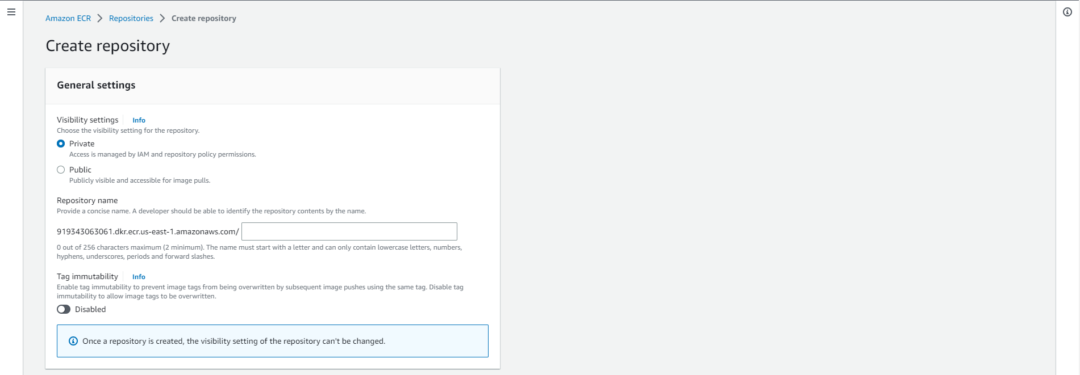  
    Naming convention should be Project-environment-service-modulename (dino-test-repository-vcon)
  + Disable the image scan settings and Encryption settings  
    Click on Create repository  
    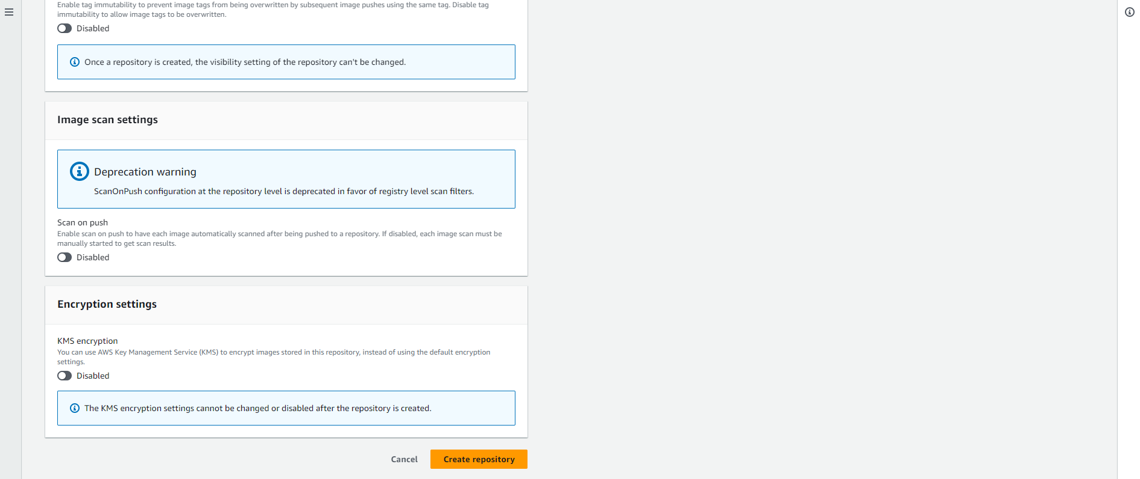
  + Your private repository will be created copy and save the URI
* ECS  
  In ECS we have to create below services.
  + Cluster
  + Task definition
  + Service
* Cluster
  + Select the new UI from AWS console in toggle button to top-left corner.  
    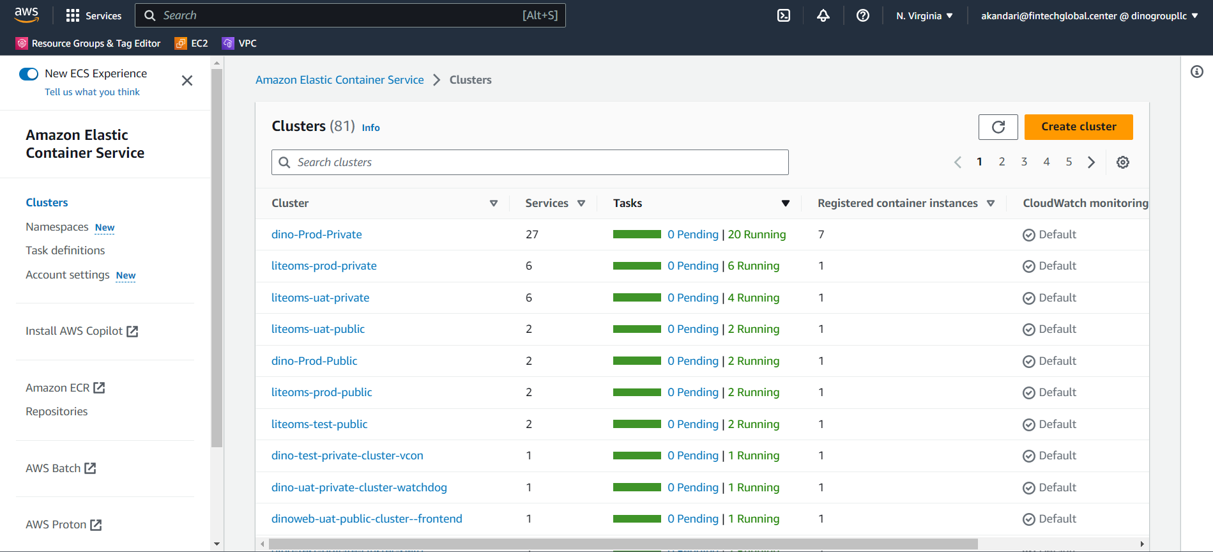
  + Click on create cluster  
    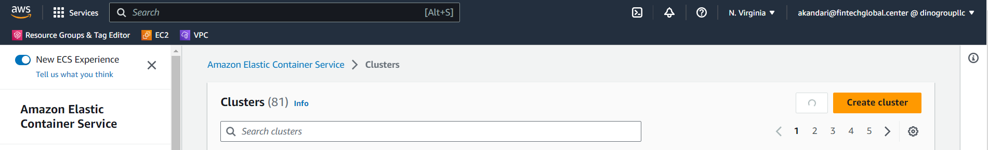
  + Enter cluster name (Project-environment-service-module)  
    Select specific environment VPC (for ICE Bondpoint and TMC, please select Dino-ice-vpc)  
    select proper subnet for private and public module  
    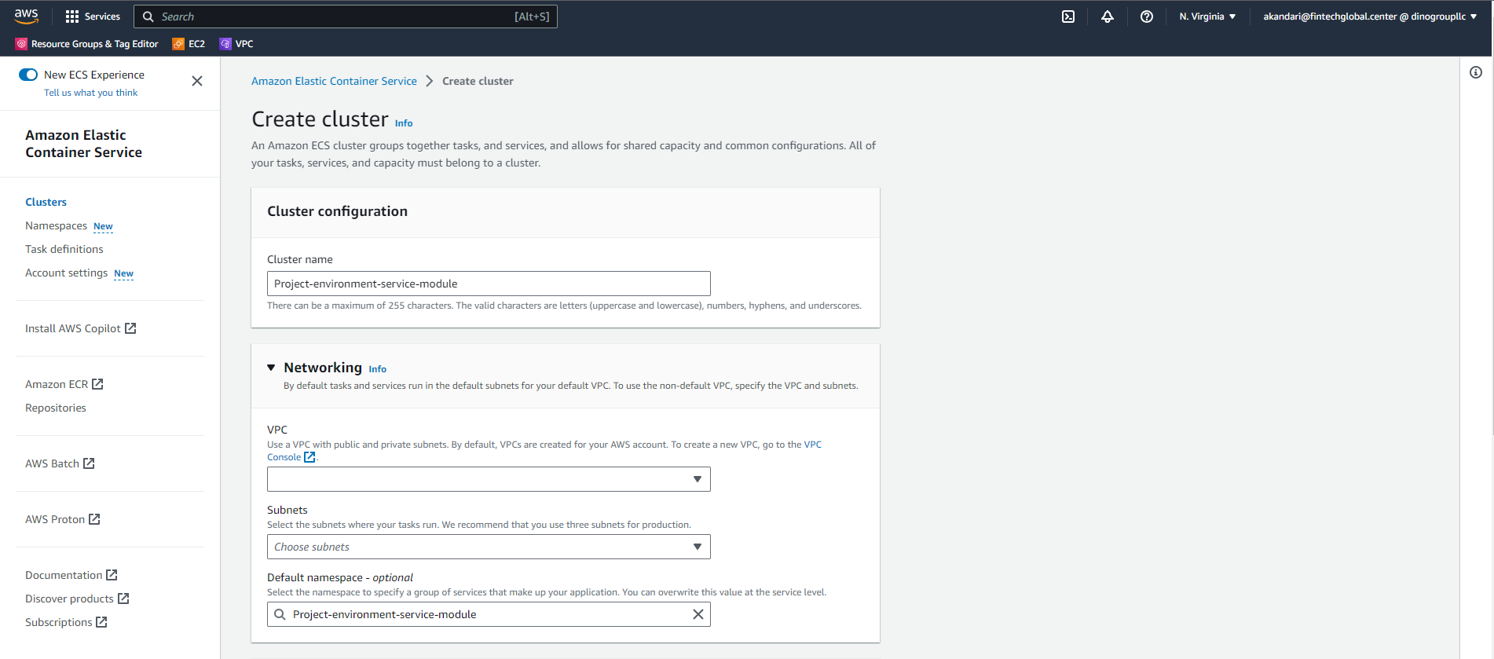
  + Inside Infrastructure   
    Select Amazon EC2 instances  
    Select “create new ASG” in Auto scaling group (ASG)  
    Select “Amazon linux 2” in operating system  
    Select Ec2 instance type depending on the module  
    Select Desired capacity as min 0 and max 0  
    Select SSH key pair depending on the environment  
    Add proper tags as below  
    Name – cluster name  
    Environment – Test/UAT/Prod  
    Resource Type – Service Name  
    Click on Create  
    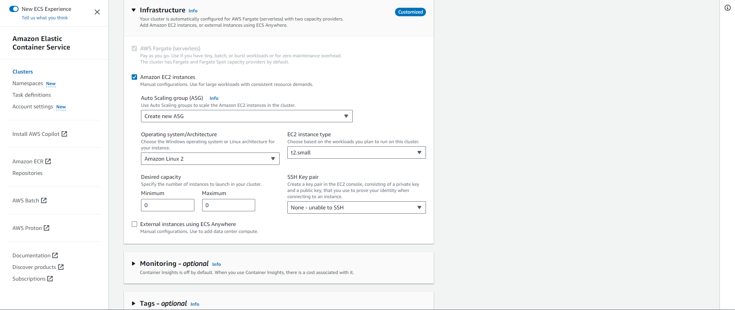
* Task Definition
  + Select the old UI from AWS console in toggle button to top-left corner.  
    Inside ECS click on Task definition in left navigation bar  
    click on create new Task Definition  
    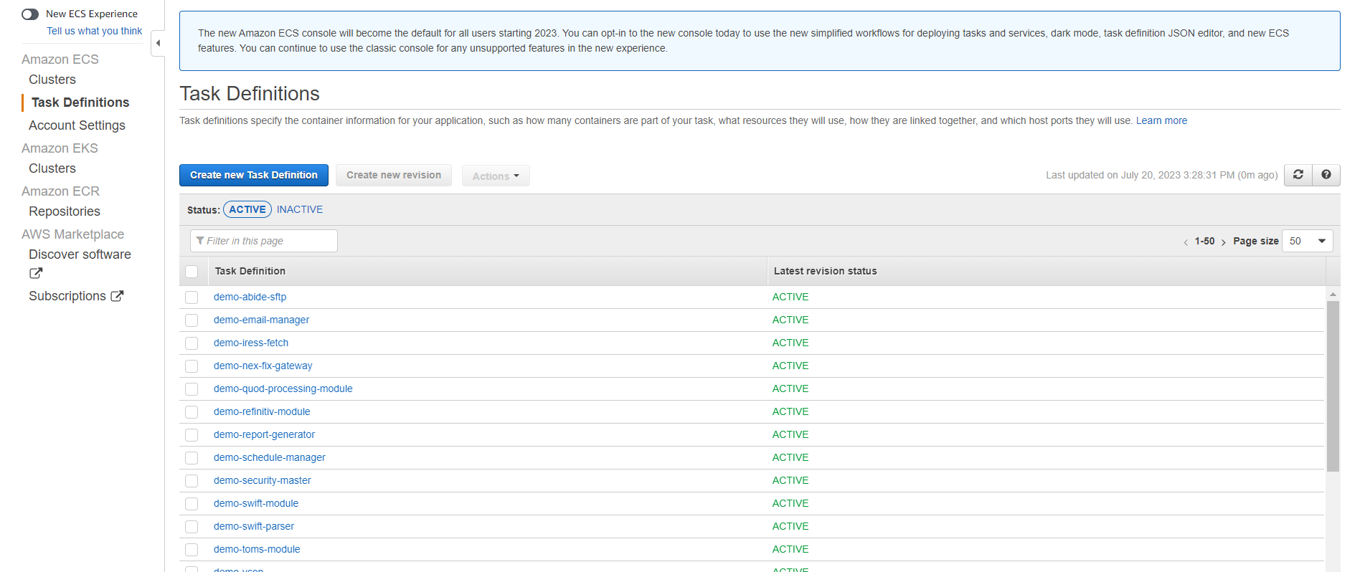
  + Select Launch Type as EC2 as cluster in which task are deployed are also in EC2.  
    Click on Next.  
    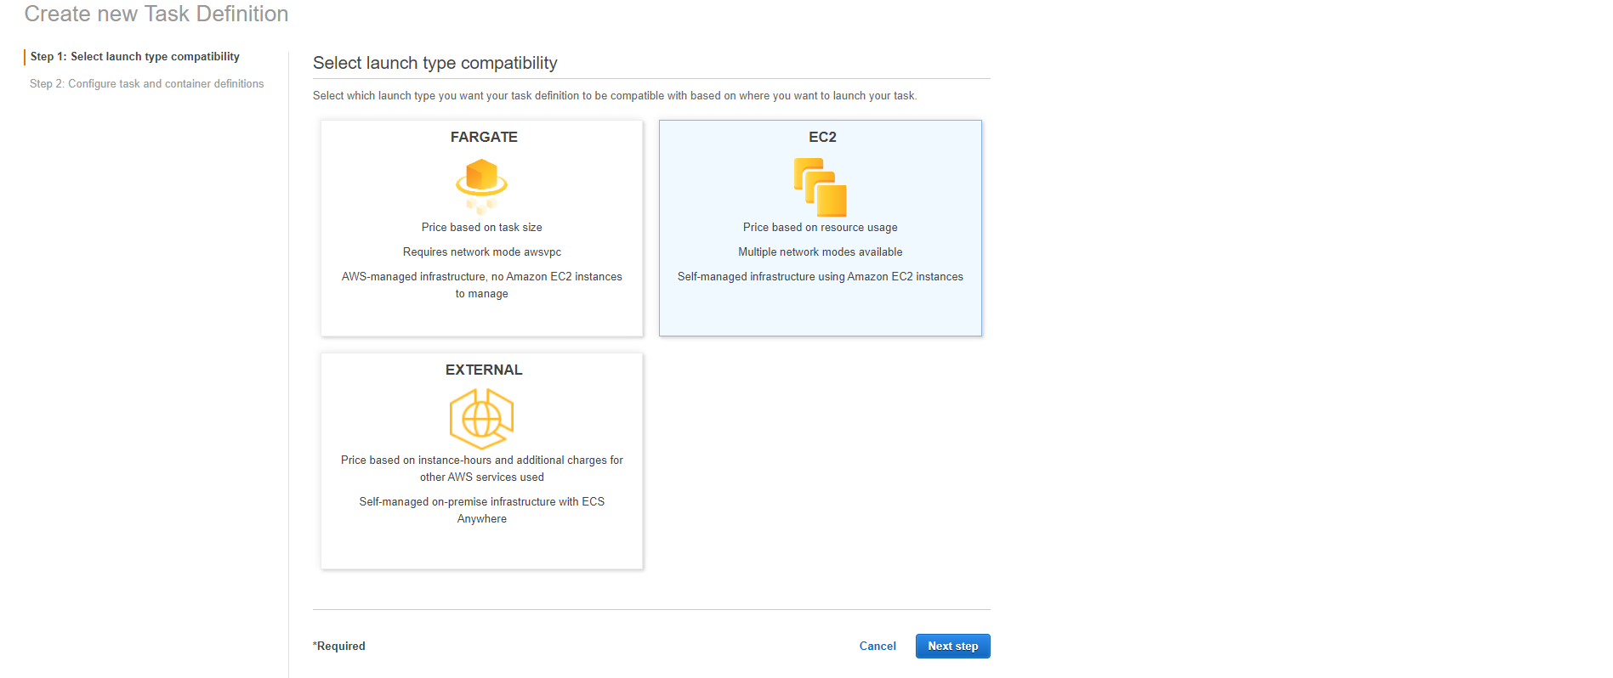
  + We need to configure the Task and Container definition  
    Enter Task Name  
    Select Task role as “ecsTaskExecutionRole”  
    Keep the Network mode as <Default>  
    Select Task Execution role as “ecsTaskExecutionRole”  
    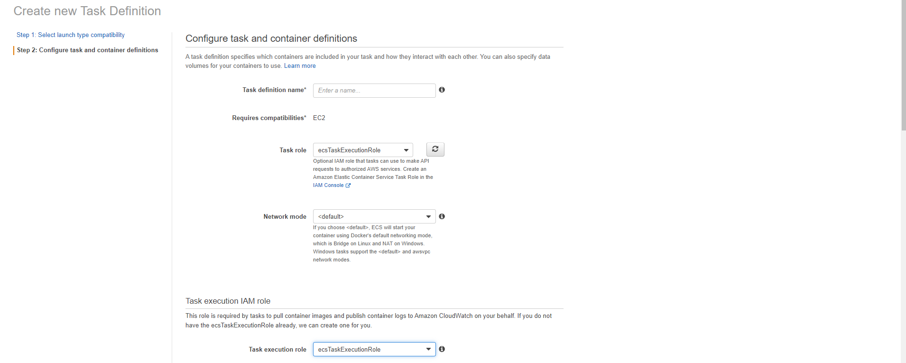
  + Task size should be left as blank  
    click on Add container  
    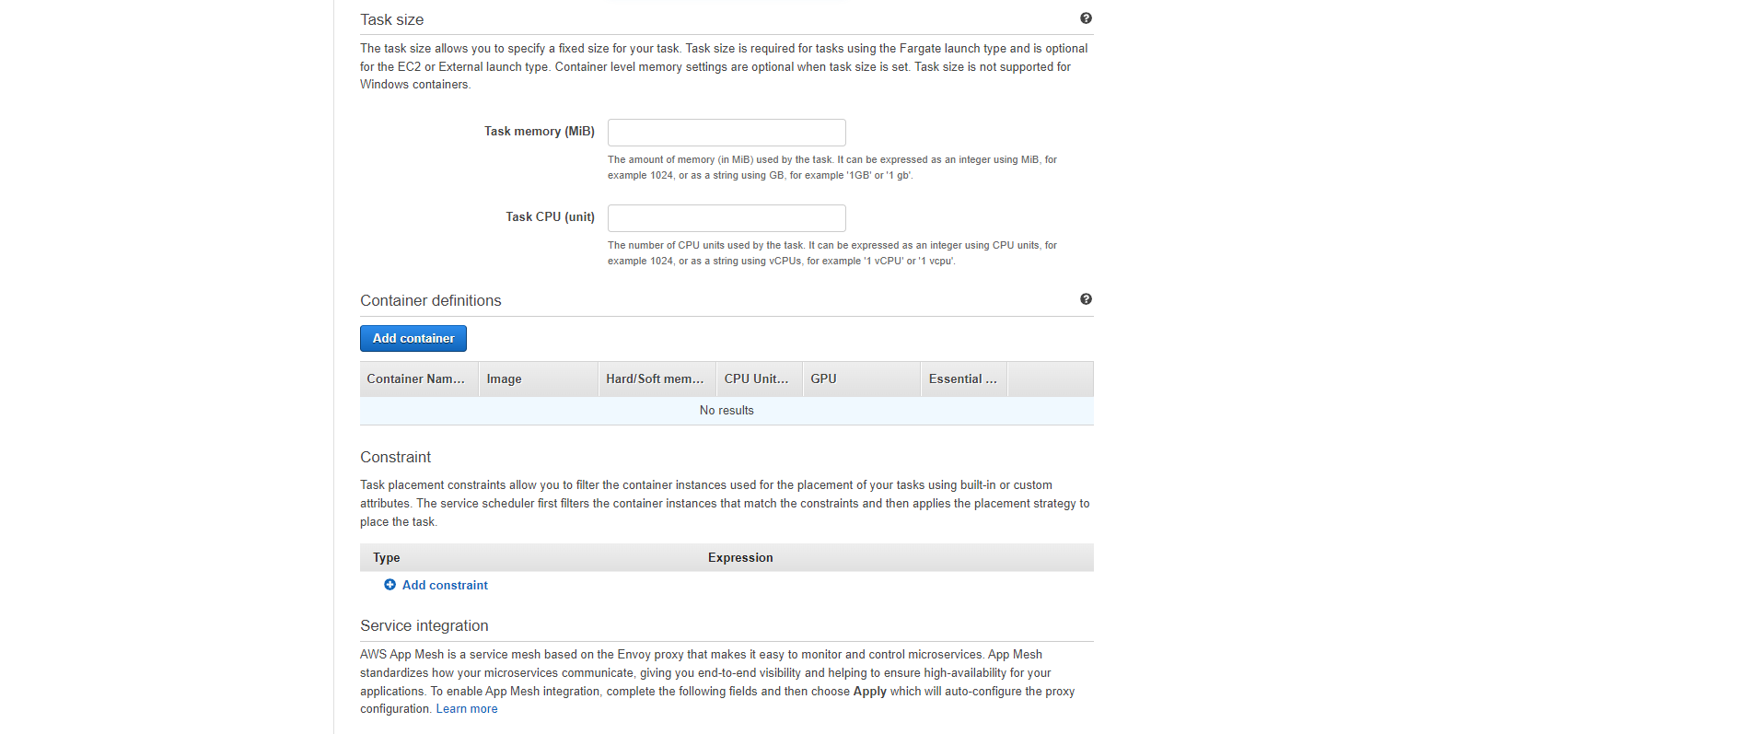
  + Enter Container Name   
    Enter the URI which we saved from ECR in image section.  
    Select memory limit as soft and 200  
    If there are any port mapping add   
    Tick mark the logs to save logs in cloud watch  
    Click on ADD  
    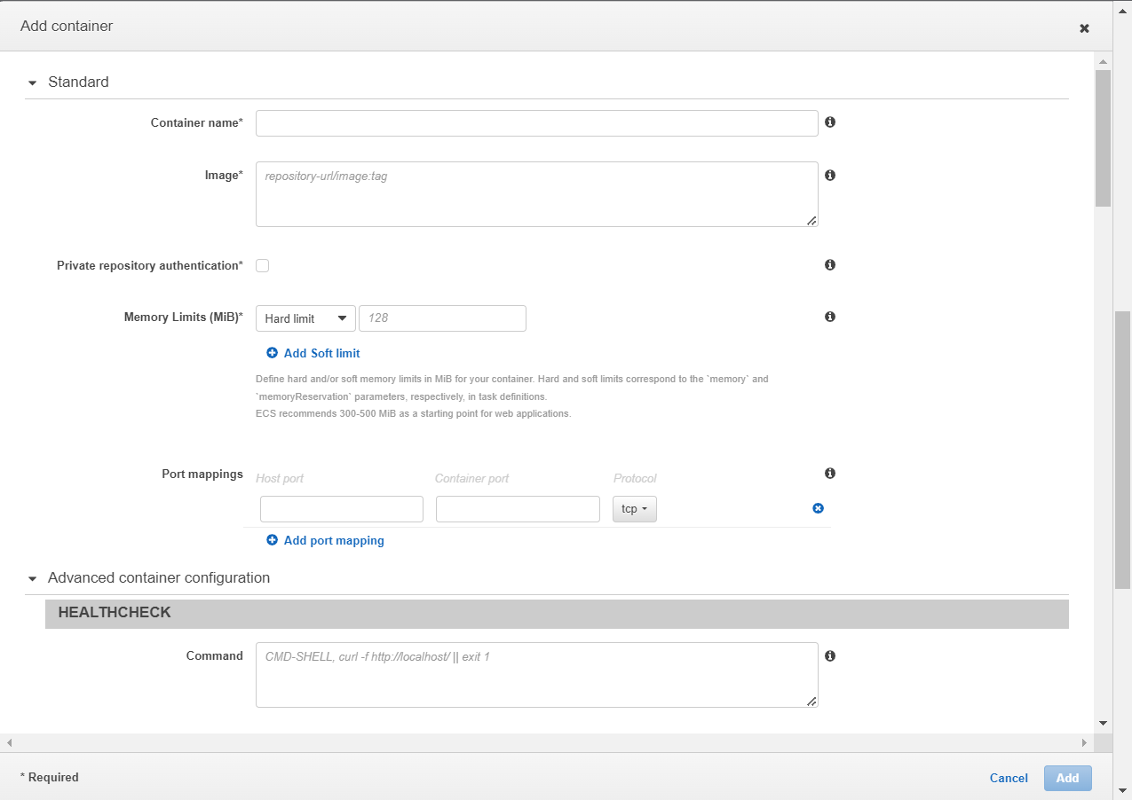
  + Click on create  
    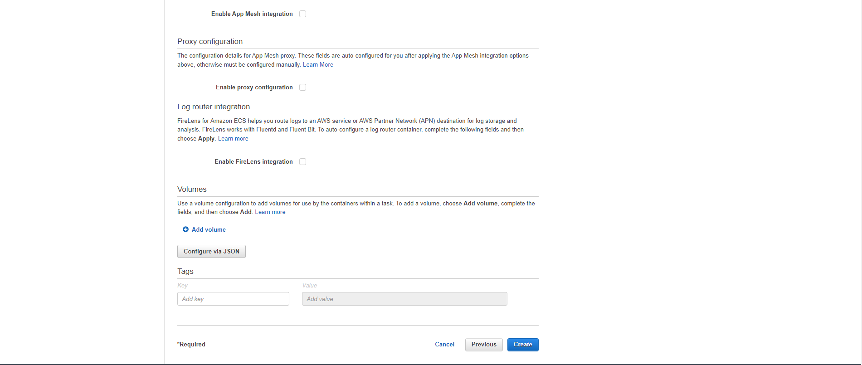
* Service
  + Click on cluster and select the cluster name you want to create service for  
    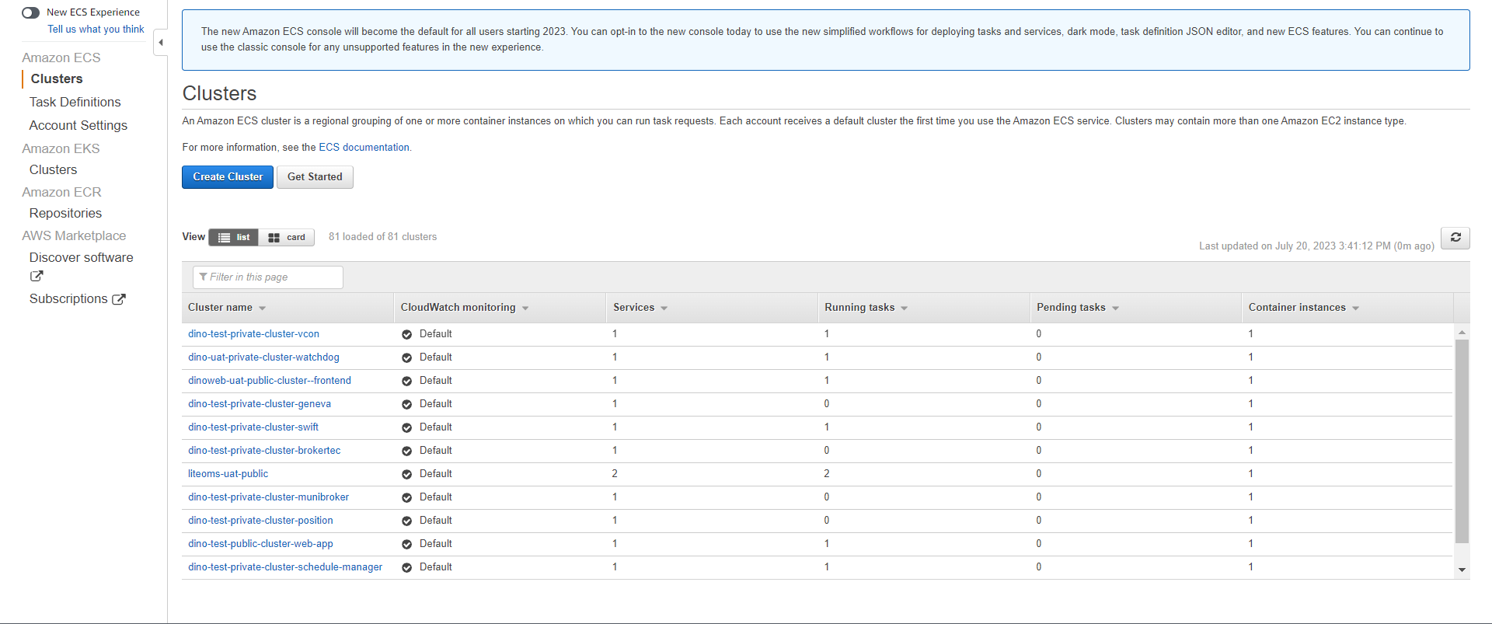
  + Select the service Tab  
    Click on Create  
    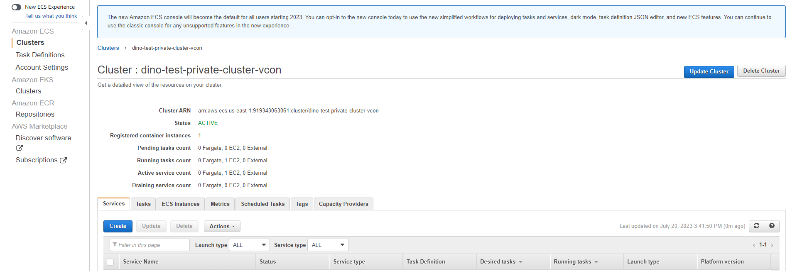
  + Select the Task definition for the module to be deployed  
    Select the revsion number  
    Select the cluster name   
    Add service Name  
    Service Type as Replica  
    Number of Task should be 1 to Run the Task and 0 to Stop the Task  
    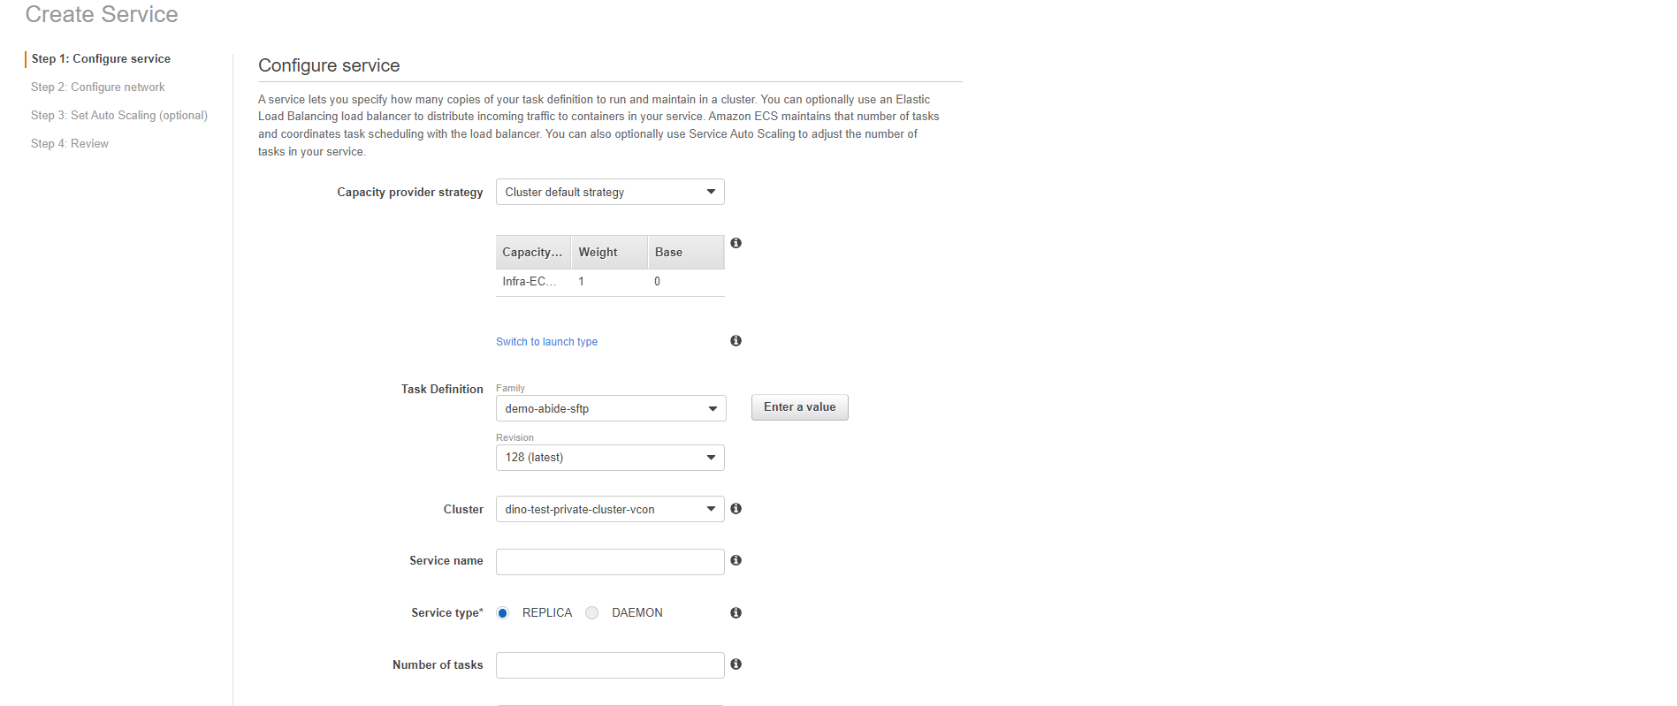  
    Click on Next step  
    Select the Load balancer if any   
    click on Next Step   
      
    Do not adjust the Auto scaling  
    click on Next  
    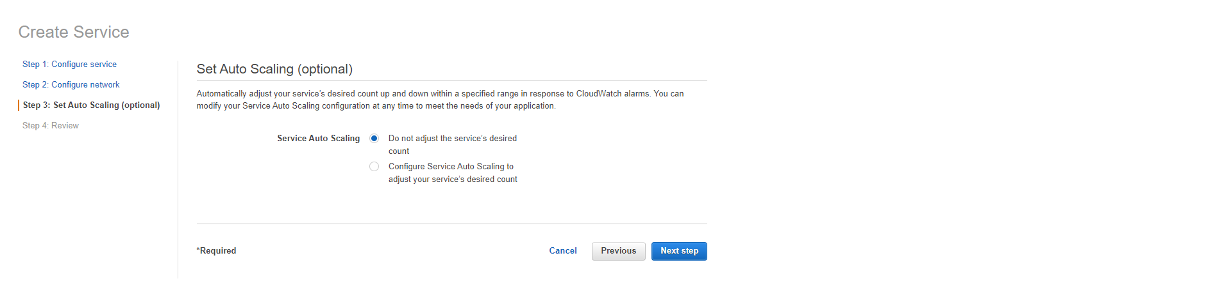  
    Review the service  
    if all okay click on Create Service  
    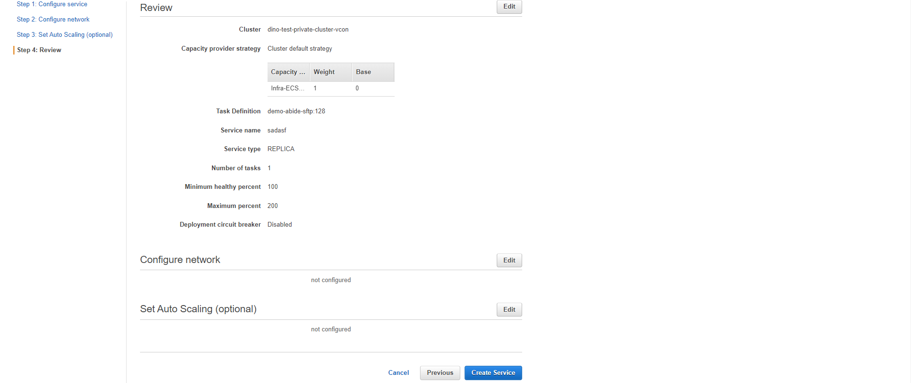
* Codebuild
  + Select Build Projects in left navigation bar inside codebuild.  
    Click on  
    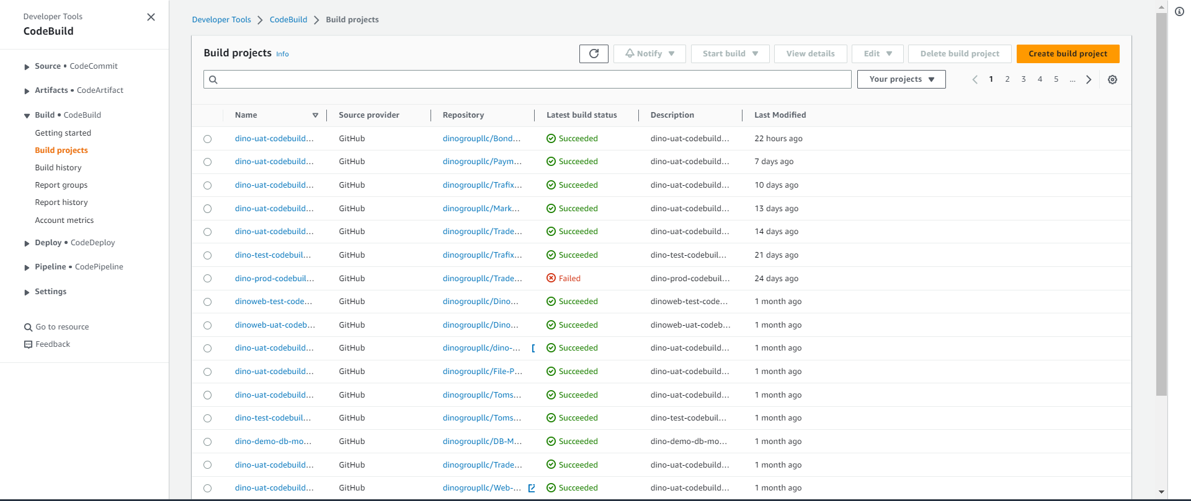
  + Enter Project Name  
    enable the Build Badge  
    Add Tags  
    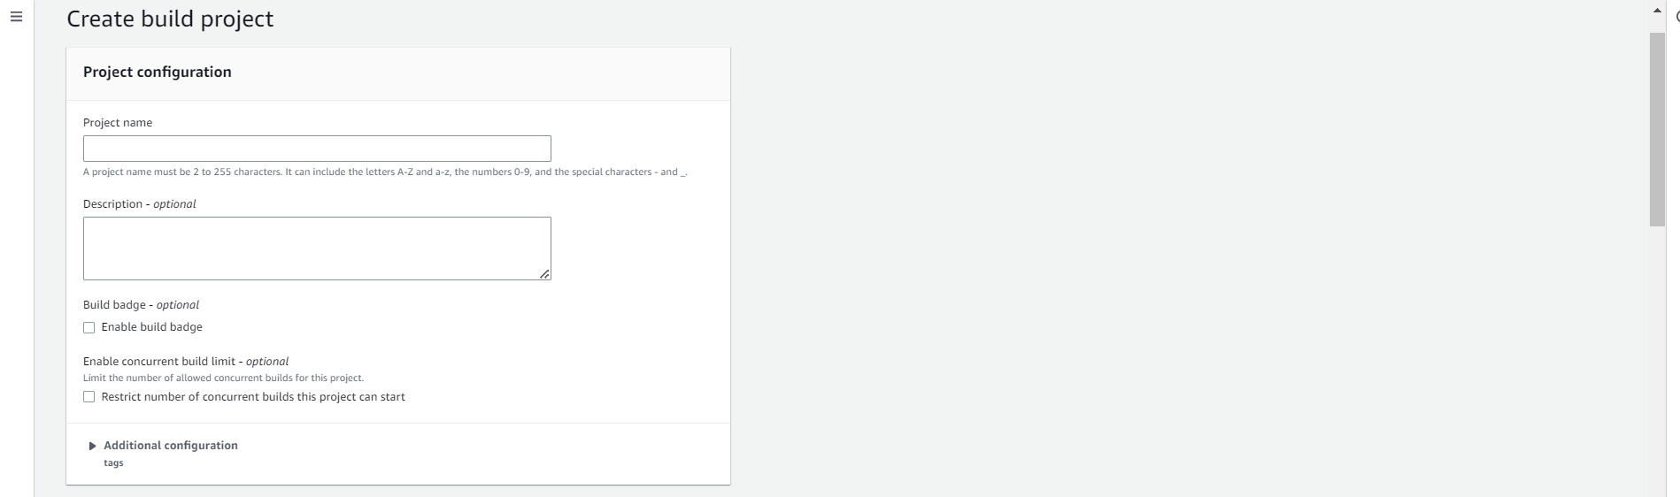
  + Inside Source   
    Select provider as Github  
    Select Repository as Repository in Github account  
    Select the module in Github Repository  
    Enter Source version as Branch in Github  
    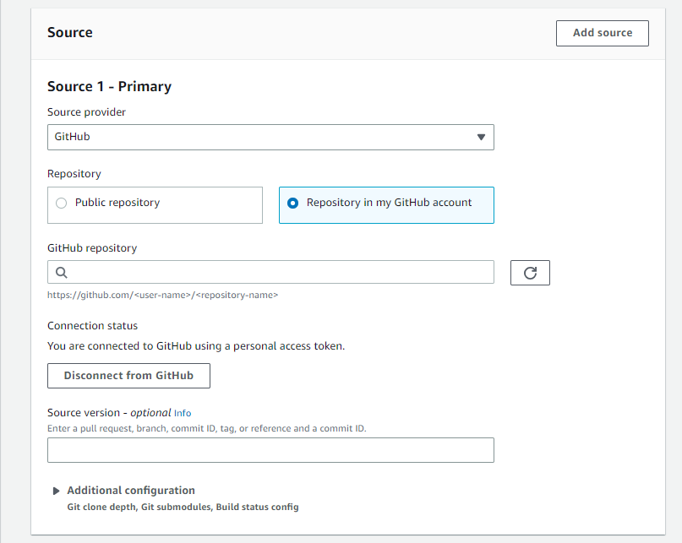
  + Inside primary source webhook events  
    Select Webhook to automate to start the build when tag is done  
    Build type as single  
    Select all event type  
    inside start a build inside head ref enter the tag name  
    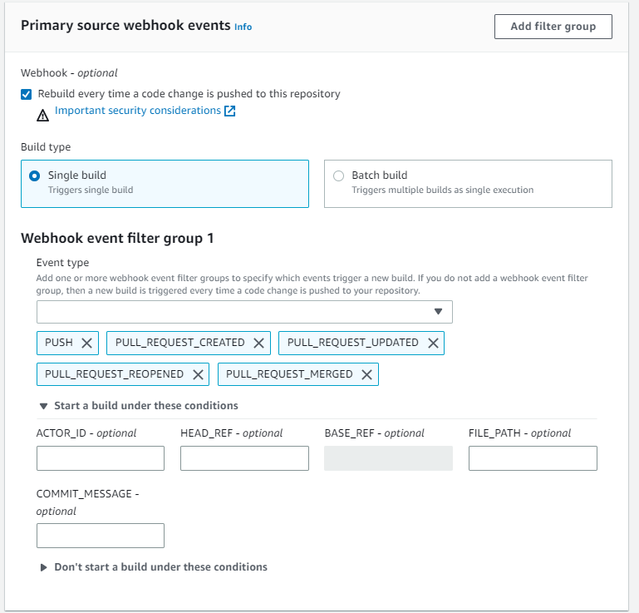
  + Inside Environment  
    Select image as managed image  
    Operating system as Amazon Linux 2  
    Runtime as standard  
    Image as the latest version  
    Image version as latest  
    Enable the privileged  
    Create a new service role   
    and enter Role name  
    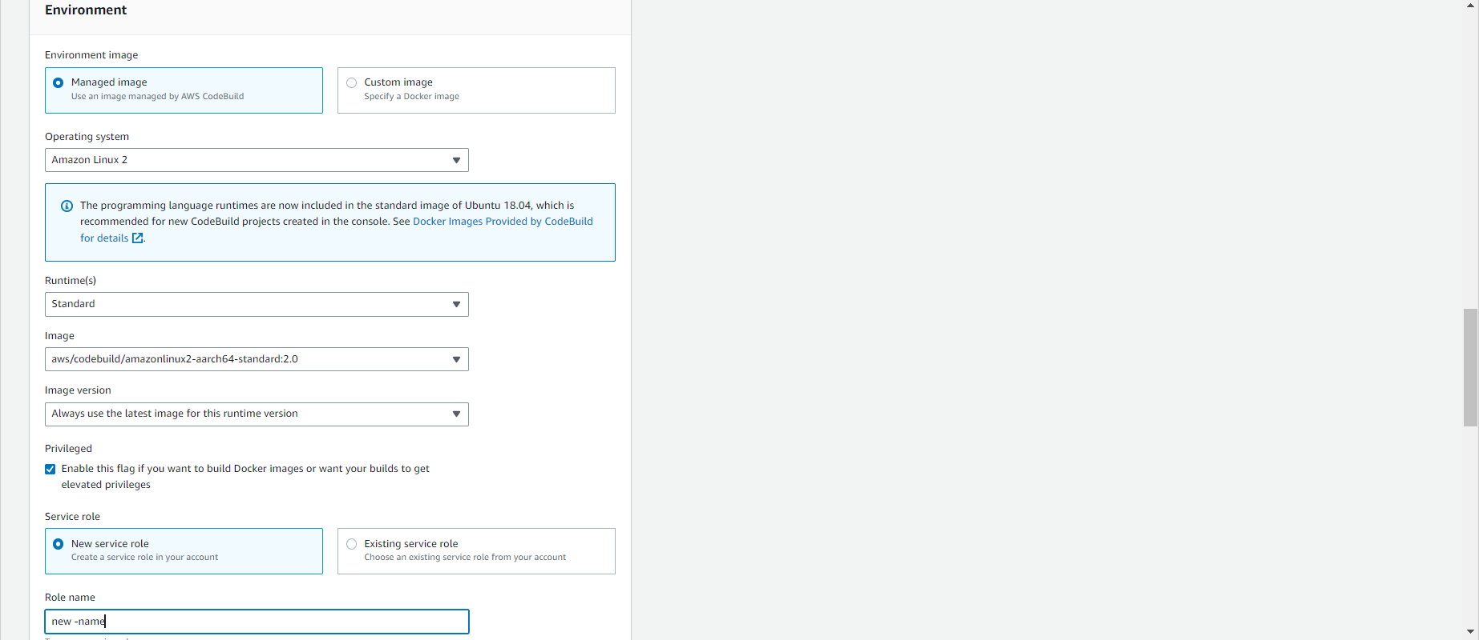
  + Inside Buildspec  
    Select Insert build commands  
    Enter the Build spec for the module (Ask developer)  
    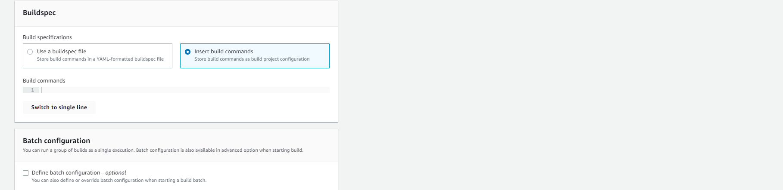
  + Click on Create Build  
    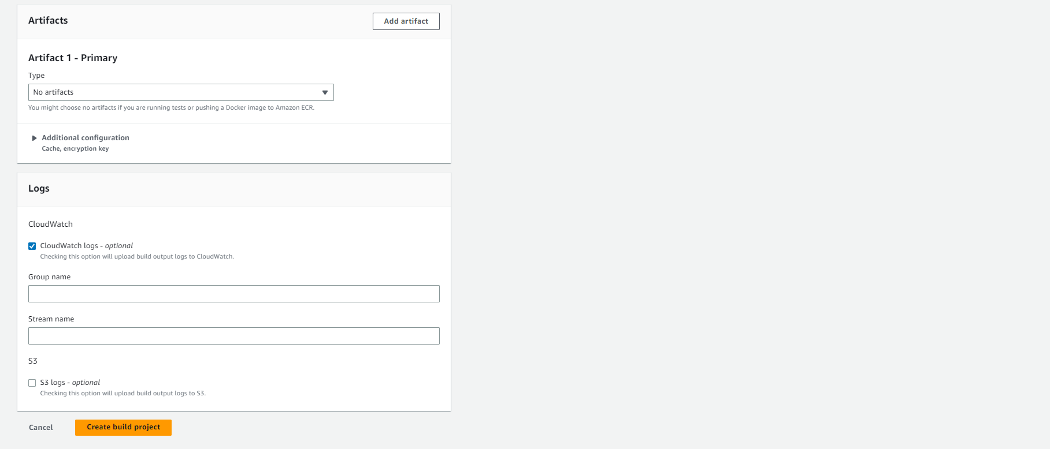
* IAM Permission for service role
  + Select the IAM role  
    Click on Add Permissions and add ECS, ECR and S3 full access to the role  
    